Homework #5

CSC 452

Zehong Zhuang

**JDBC**

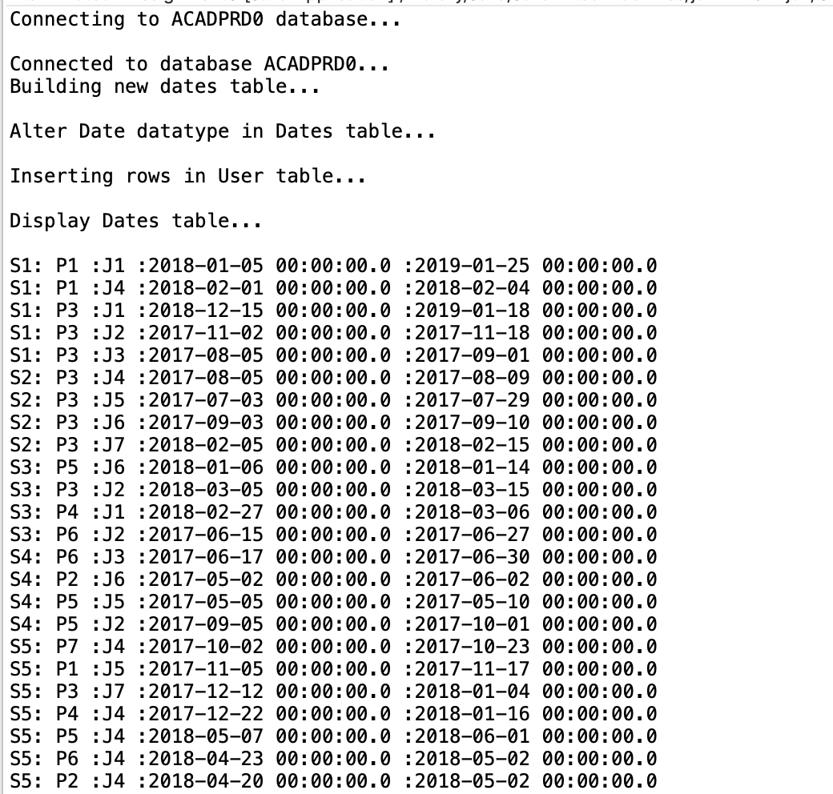

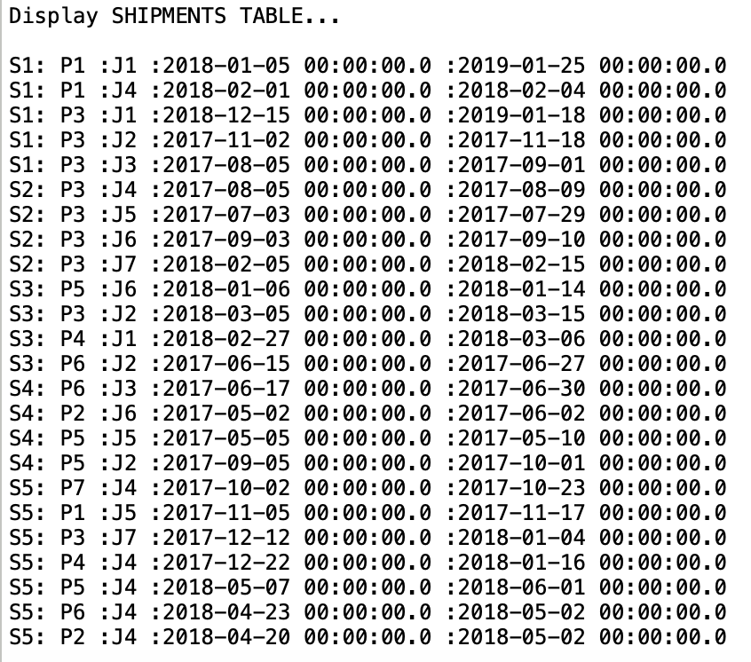

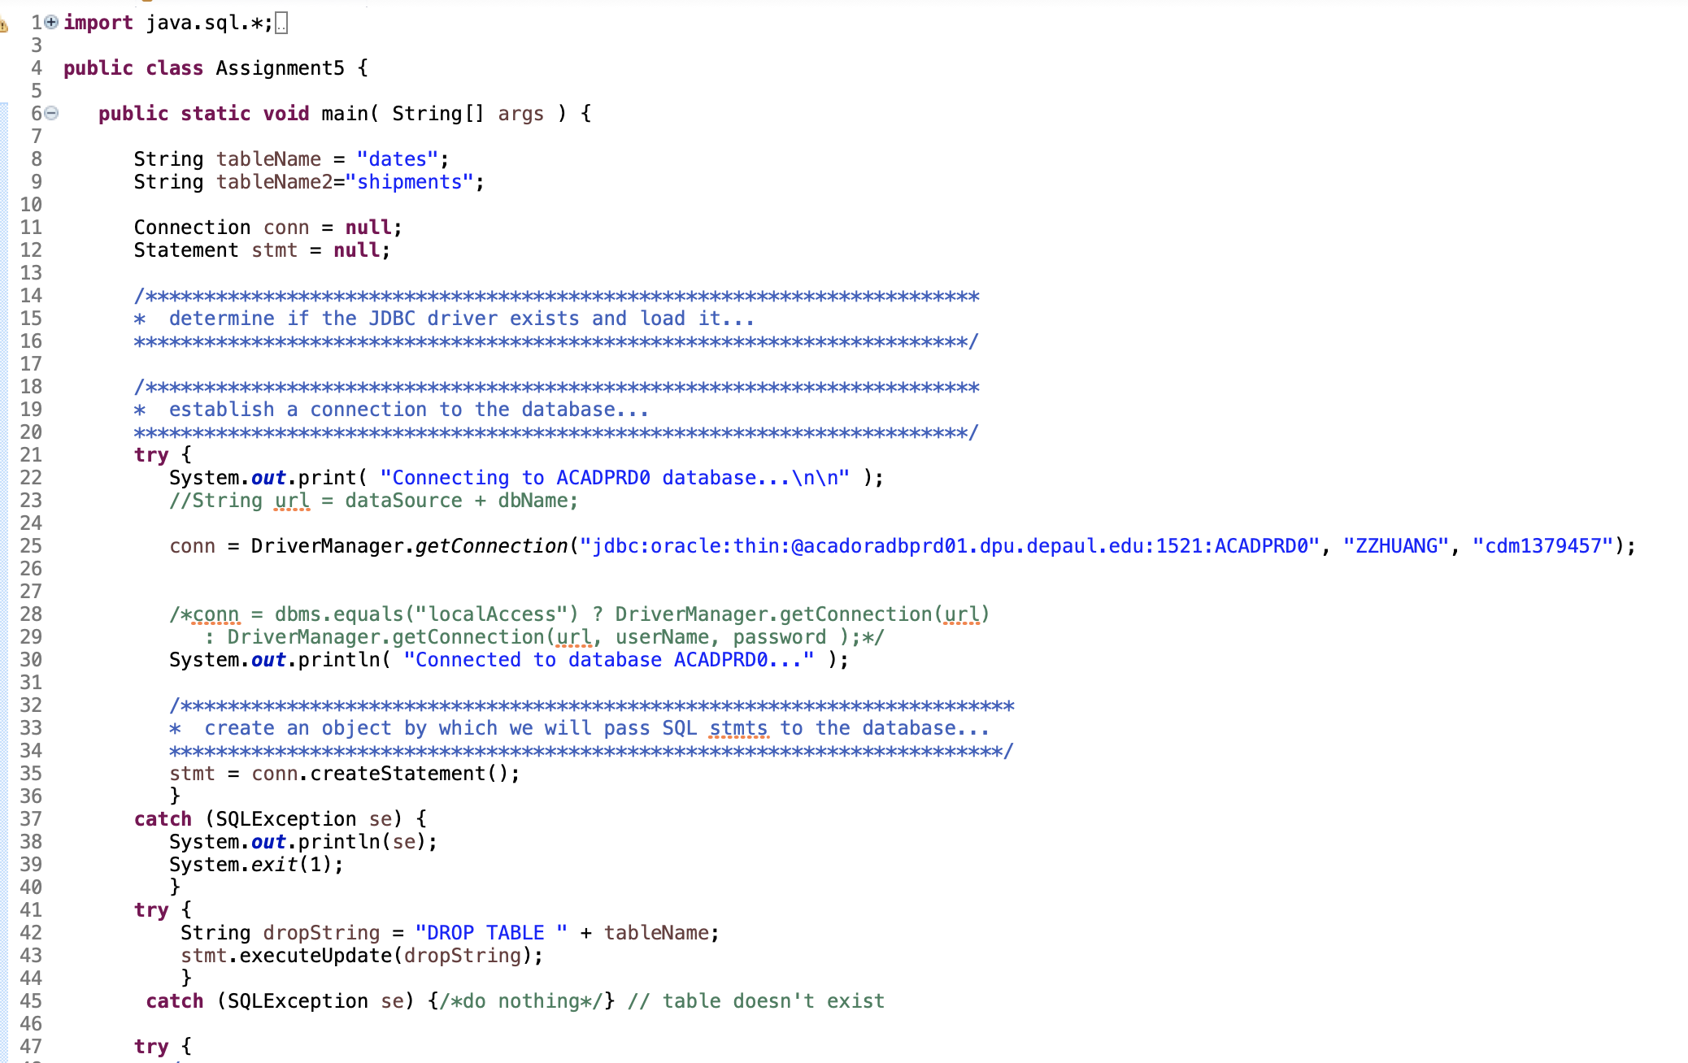

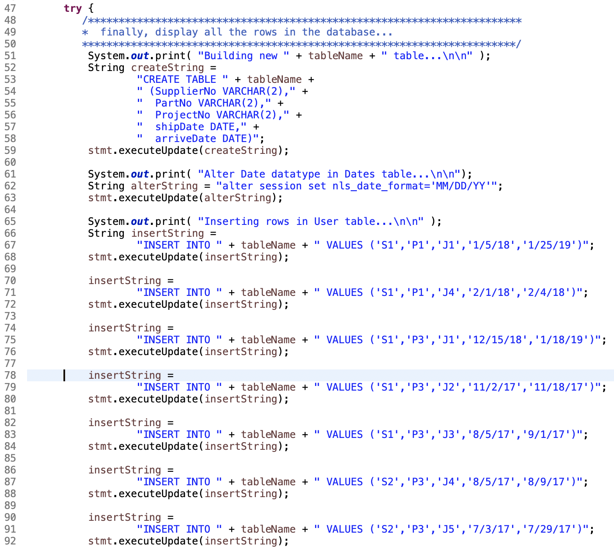

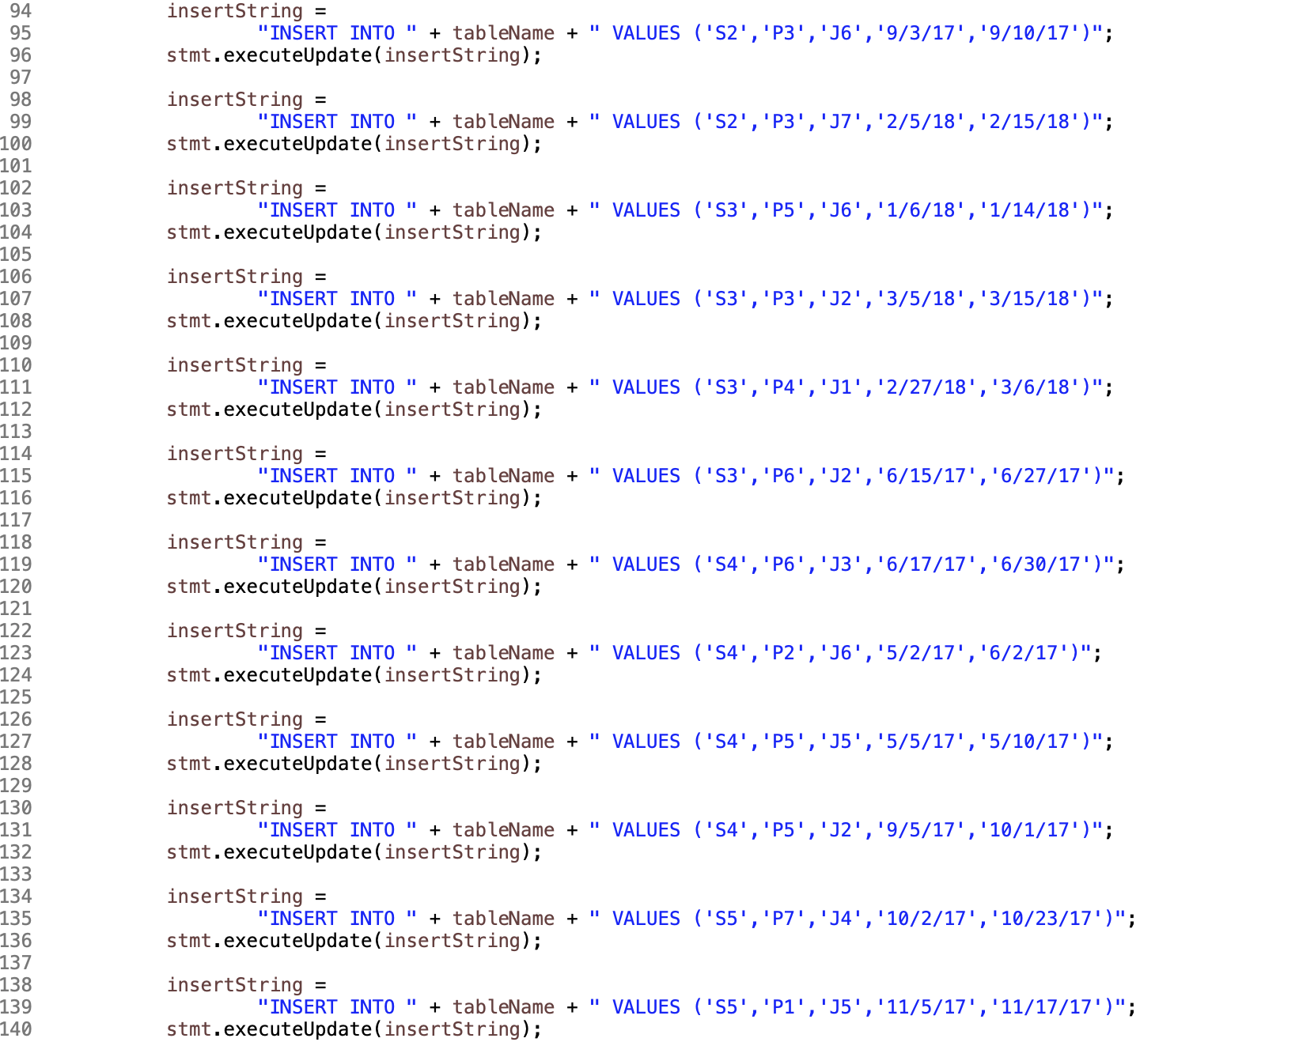

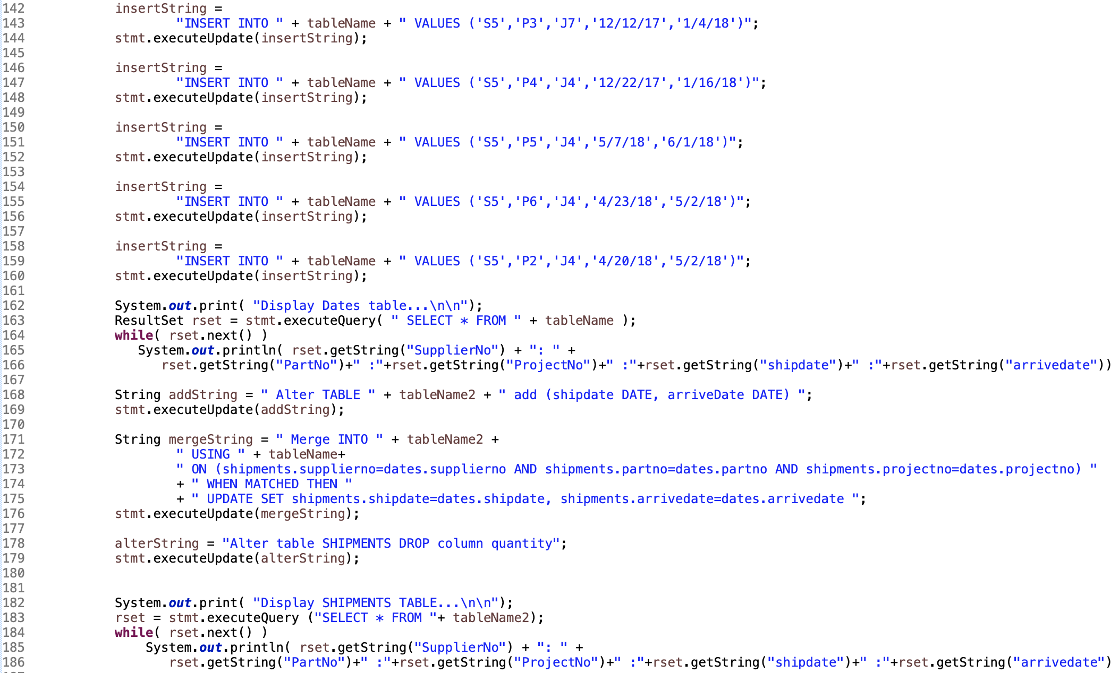

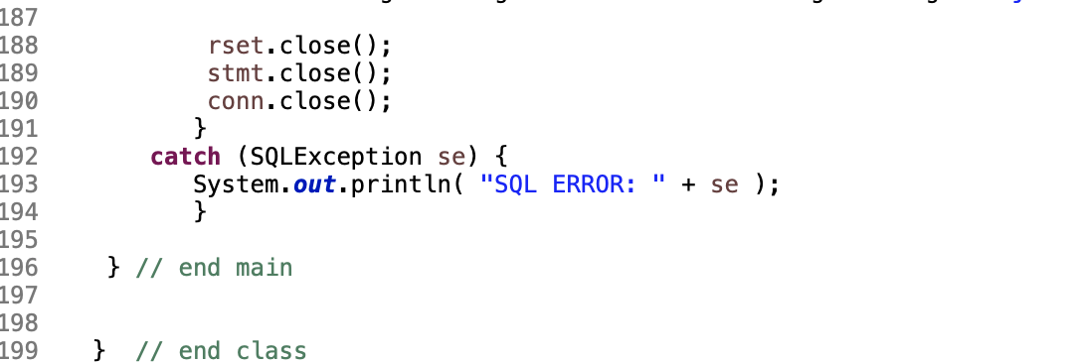

PL/SQL

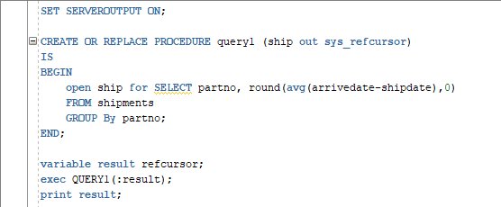

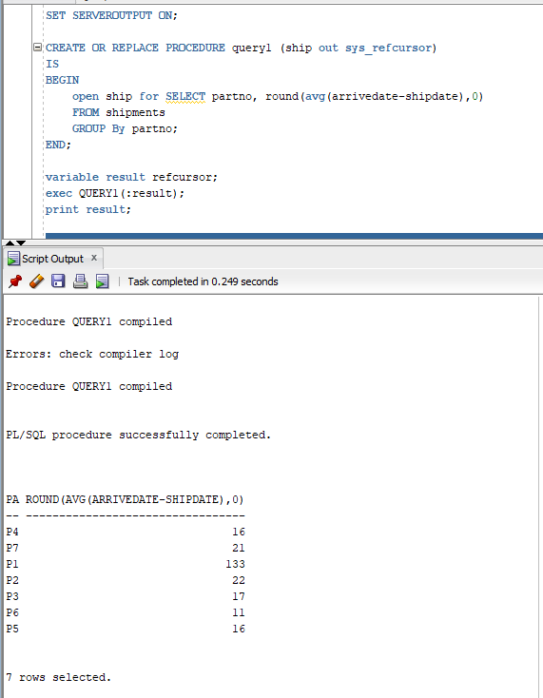

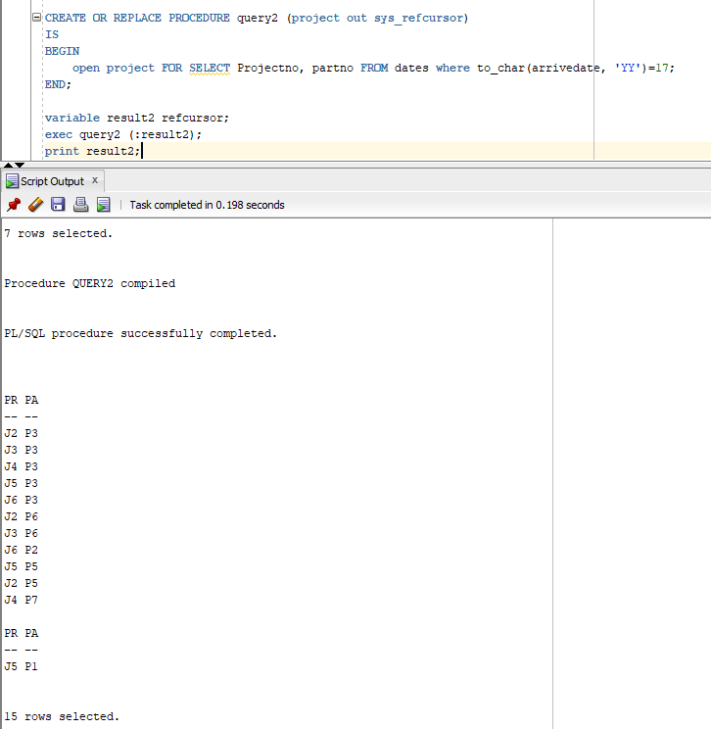

**PL/SQL Codes**

SET SERVEROUTPUT ON;

CREATE OR REPLACE PROCEDURE query1 (ship out sys_refcursor)

IS

BEGIN

open ship for SELECT partno, round(avg(arrivedate-shipdate),0)

FROM shipments

GROUP By partno;

END;

variable result refcursor;

exec QUERY1(:result);

print result;

CREATE OR REPLACE PROCEDURE query2 (project out sys_refcursor)

IS

BEGIN

open project FOR SELECT Projectno, partno FROM dates where to_char(arrivedate, 'YY')=17;

END;

variable result2 refcursor;

exec query2 (:result2);

print result2;

**Java**

**import java.sql.*;**

**import java.io.*;**

**public class Assignment5 {**

**public static void main( String[] args ) {**

**String tableName = "dates";**

**String tableName2="shipments";**

**Connection conn = null;**

**Statement stmt = null;**

**/\*\*\*\*\*\*\*\*\*\*\*\*\*\*\*\*\*\*\*\*\*\*\*\*\*\*\*\*\*\*\*\*\*\*\*\*\*\*\*\*\*\*\*\*\*\*\*\*\*\*\*\*\*\*\*\*\*\*\*\*\*\*\*\*\*\*\*\*\*\*\***

**\* determine if the JDBC driver exists and load it...**

**\*\*\*\*\*\*\*\*\*\*\*\*\*\*\*\*\*\*\*\*\*\*\*\*\*\*\*\*\*\*\*\*\*\*\*\*\*\*\*\*\*\*\*\*\*\*\*\*\*\*\*\*\*\*\*\*\*\*\*\*\*\*\*\*\*\*\*\*\*\*\*/**

**/\*\*\*\*\*\*\*\*\*\*\*\*\*\*\*\*\*\*\*\*\*\*\*\*\*\*\*\*\*\*\*\*\*\*\*\*\*\*\*\*\*\*\*\*\*\*\*\*\*\*\*\*\*\*\*\*\*\*\*\*\*\*\*\*\*\*\*\*\*\*\***

**\* establish a connection to the database...**

**\*\*\*\*\*\*\*\*\*\*\*\*\*\*\*\*\*\*\*\*\*\*\*\*\*\*\*\*\*\*\*\*\*\*\*\*\*\*\*\*\*\*\*\*\*\*\*\*\*\*\*\*\*\*\*\*\*\*\*\*\*\*\*\*\*\*\*\*\*\*\*/**

**try {**

**System.out.print( "Connecting to ACADPRD0 database...\n\n" );**

**//String url = dataSource + dbName;**

**conn = DriverManager.getConnection("jdbc:oracle:thin:@acadoradbprd01.dpu.depaul.edu:1521:ACADPRD0", "ZZHUANG", "cdm1379457");**

**/*conn = dbms.equals("localAccess") ? DriverManager.getConnection(url)**

**: DriverManager.getConnection(url, userName, password );*/**

**System.out.println( "Connected to database ACADPRD0..." );**

**/\*\*\*\*\*\*\*\*\*\*\*\*\*\*\*\*\*\*\*\*\*\*\*\*\*\*\*\*\*\*\*\*\*\*\*\*\*\*\*\*\*\*\*\*\*\*\*\*\*\*\*\*\*\*\*\*\*\*\*\*\*\*\*\*\*\*\*\*\*\*\***

**\* create an object by which we will pass SQL stmts to the database...**

**\*\*\*\*\*\*\*\*\*\*\*\*\*\*\*\*\*\*\*\*\*\*\*\*\*\*\*\*\*\*\*\*\*\*\*\*\*\*\*\*\*\*\*\*\*\*\*\*\*\*\*\*\*\*\*\*\*\*\*\*\*\*\*\*\*\*\*\*\*\*\*/**

**stmt = conn.createStatement();**

**}**

**catch (SQLException se) {**

**System.out.println(se);**

**System.exit(1);**

**}**

**try {**

**String dropString = "DROP TABLE " + tableName;**

**stmt.executeUpdate(dropString);**

**}**

**catch (SQLException se) {/*do nothing*/} // table doesn't exist**

**try {**

**/\*\*\*\*\*\*\*\*\*\*\*\*\*\*\*\*\*\*\*\*\*\*\*\*\*\*\*\*\*\*\*\*\*\*\*\*\*\*\*\*\*\*\*\*\*\*\*\*\*\*\*\*\*\*\*\*\*\*\*\*\*\*\*\*\*\*\*\*\*\*\***

**\* finally, display all the rows in the database...**

**\*\*\*\*\*\*\*\*\*\*\*\*\*\*\*\*\*\*\*\*\*\*\*\*\*\*\*\*\*\*\*\*\*\*\*\*\*\*\*\*\*\*\*\*\*\*\*\*\*\*\*\*\*\*\*\*\*\*\*\*\*\*\*\*\*\*\*\*\*\*\*/**

**System.out.print( "Building new " + tableName + " table...\n\n" );**

**String createString =**

**"CREATE TABLE " + tableName +**

**" (SupplierNo VARCHAR(2)," +**

**" PartNo VARCHAR(2)," +**

**" ProjectNo VARCHAR(2)," +**

**" shipDate DATE," +**

**" arriveDate DATE)";**

**stmt.executeUpdate(createString);**

**System.out.print( "Alter Date datatype in Dates table...\n\n");**

**String alterString = "alter session set nls_date_format='MM/DD/YY'";**

**stmt.executeUpdate(alterString);**

**System.out.print( "Inserting rows in User table...\n\n" );**

**String insertString =**

**"INSERT INTO " + tableName + " VALUES ('S1','P1','J1','1/5/18','1/25/19')";**

**stmt.executeUpdate(insertString);**

**insertString =**

**"INSERT INTO " + tableName + " VALUES ('S1','P1','J4','2/1/18','2/4/18')";**

**stmt.executeUpdate(insertString);**

**insertString =**

**"INSERT INTO " + tableName + " VALUES ('S1','P3','J1','12/15/18','1/18/19')";**

**stmt.executeUpdate(insertString);**

**insertString =**

**"INSERT INTO " + tableName + " VALUES ('S1','P3','J2','11/2/17','11/18/17')";**

**stmt.executeUpdate(insertString);**

**insertString =**

**"INSERT INTO " + tableName + " VALUES ('S1','P3','J3','8/5/17','9/1/17')";**

**stmt.executeUpdate(insertString);**

**insertString =**

**"INSERT INTO " + tableName + " VALUES ('S2','P3','J4','8/5/17','8/9/17')";**

**stmt.executeUpdate(insertString);**

**insertString =**

**"INSERT INTO " + tableName + " VALUES ('S2','P3','J5','7/3/17','7/29/17')";**

**stmt.executeUpdate(insertString);**

**insertString =**

**"INSERT INTO " + tableName + " VALUES ('S2','P3','J6','9/3/17','9/10/17')";**

**stmt.executeUpdate(insertString);**

**insertString =**

**"INSERT INTO " + tableName + " VALUES ('S2','P3','J7','2/5/18','2/15/18')";**

**stmt.executeUpdate(insertString);**

**insertString =**

**"INSERT INTO " + tableName + " VALUES ('S3','P5','J6','1/6/18','1/14/18')";**

**stmt.executeUpdate(insertString);**

**insertString =**

**"INSERT INTO " + tableName + " VALUES ('S3','P3','J2','3/5/18','3/15/18')";**

**stmt.executeUpdate(insertString);**

**insertString =**

**"INSERT INTO " + tableName + " VALUES ('S3','P4','J1','2/27/18','3/6/18')";**

**stmt.executeUpdate(insertString);**

**insertString =**

**"INSERT INTO " + tableName + " VALUES ('S3','P6','J2','6/15/17','6/27/17')";**

**stmt.executeUpdate(insertString);**

**insertString =**

**"INSERT INTO " + tableName + " VALUES ('S4','P6','J3','6/17/17','6/30/17')";**

**stmt.executeUpdate(insertString);**

**insertString =**

**"INSERT INTO " + tableName + " VALUES ('S4','P2','J6','5/2/17','6/2/17')";**

**stmt.executeUpdate(insertString);**

**insertString =**

**"INSERT INTO " + tableName + " VALUES ('S4','P5','J5','5/5/17','5/10/17')";**

**stmt.executeUpdate(insertString);**

**insertString =**

**"INSERT INTO " + tableName + " VALUES ('S4','P5','J2','9/5/17','10/1/17')";**

**stmt.executeUpdate(insertString);**

**insertString =**

**"INSERT INTO " + tableName + " VALUES ('S5','P7','J4','10/2/17','10/23/17')";**

**stmt.executeUpdate(insertString);**

**insertString =**

**"INSERT INTO " + tableName + " VALUES ('S5','P1','J5','11/5/17','11/17/17')";**

**stmt.executeUpdate(insertString);**

**insertString =**

**"INSERT INTO " + tableName + " VALUES ('S5','P3','J7','12/12/17','1/4/18')";**

**stmt.executeUpdate(insertString);**

**insertString =**

**"INSERT INTO " + tableName + " VALUES ('S5','P4','J4','12/22/17','1/16/18')";**

**stmt.executeUpdate(insertString);**

**insertString =**

**"INSERT INTO " + tableName + " VALUES ('S5','P5','J4','5/7/18','6/1/18')";**

**stmt.executeUpdate(insertString);**

**insertString =**

**"INSERT INTO " + tableName + " VALUES ('S5','P6','J4','4/23/18','5/2/18')";**

**stmt.executeUpdate(insertString);**

**insertString =**

**"INSERT INTO " + tableName + " VALUES ('S5','P2','J4','4/20/18','5/2/18')";**

**stmt.executeUpdate(insertString);**

**System.out.print( "Display Dates table...\n\n");**

**ResultSet rset = stmt.executeQuery( " SELECT * FROM " + tableName );**

**while( rset.next() )**

**System.out.println( rset.getString("SupplierNo") + ": " +**

**rset.getString("PartNo")+" :"+rset.getString("ProjectNo")+" :"+rset.getString("shipdate")+" :"+rset.getString("arrivedate"));**

**String addString = " Alter TABLE " + tableName2 + " add (shipdate DATE, arriveDate DATE) ";**

**stmt.executeUpdate(addString);**

**String mergeString = " Merge INTO " + tableName2 +**

**" USING " + tableName+**

**" ON (shipments.supplierno=dates.supplierno AND shipments.partno=dates.partno AND shipments.projectno=dates.projectno) "**

**+ " WHEN MATCHED THEN "**

**+ " UPDATE SET shipments.shipdate=dates.shipdate, shipments.arrivedate=dates.arrivedate ";**

**stmt.executeUpdate(mergeString);**

**alterString = "Alter table SHIPMENTS DROP column quantity";**

**stmt.executeUpdate(alterString);**

**System.out.print( "Display SHIPMENTS TABLE...\n\n");**

**rset = stmt.executeQuery ("SELECT * FROM "+ tableName2);**

**while( rset.next() )**

**System.out.println( rset.getString("SupplierNo") + ": " +**

**rset.getString("PartNo")+" :"+rset.getString("ProjectNo")+" :"+rset.getString("shipdate")+" :"+rset.getString("arrivedate"));**

**rset.close();**

**stmt.close();**

**conn.close();**

**}**

**catch (SQLException se) {**

**System.out.println( "SQL ERROR: " + se );**

**}**

**} // end main**

**} // end class**